SQL basics: Task 3

Joins: Inner Join, Outer Join, Full Outer Join, Cross Join

**Useful Info:**

First, check this documentation for the topics marked by the red “v” sign. They can be useful when you do the exercise.

<https://www.w3schools.com/sql/default.asp>

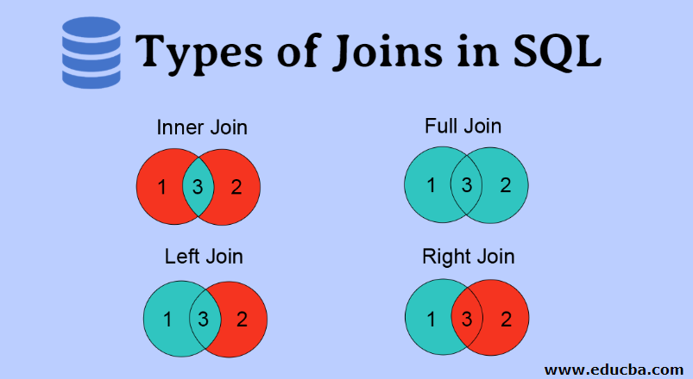

**Exercise:**

Write SQL queries using HR schema data for:

1. Task 1(Show First and Last name of the manager and the number of his/her subordinates), 2, 4, 6, 7, 8, 10 (with county name in the output) from **SQL.pdf file**

As a result, you need to have:

1. Task3_<Name_Surname>.sql file
2. Task3_<Name_Surname>.docx file with screenshots of query results

Commit your files to “Result” folder under “Task 3” folder.